♪♫ Hampton City Schools Jazz Ensemble ♪♫
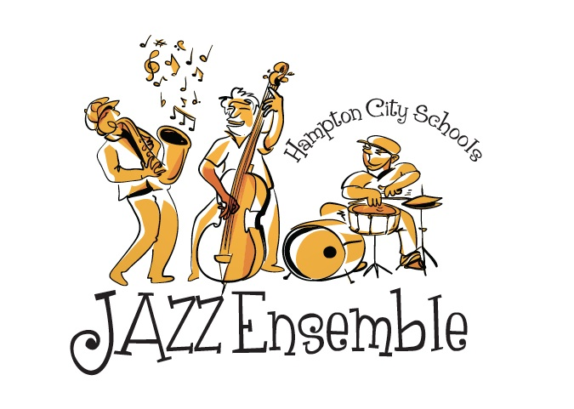
Mr. Scott Schneider – Director
sschneider@hampton.k12.va.us
757-268-3506 – office

What is it?: The Hampton City Schools Jazz Ensemble recognizes and honors talented H.S. and M.S. musicians in the city of Hampton. The purpose of this honors ensemble is to give exceptional jazz musicians more instruction in the jazz genre and with improvisation, and to allow more open doors for performances and gigs.

Instrumentation and “First Read”: Ensemble is open to all middle school and high school musicians, including those that don’t play traditional jazz band instruments. Students must be a member of their own school’s concert band, but don’t need to have any previous jazz experience. All participants need to be recommended by their director. Any middle or high school musician who was placed in the All-District Honor Band last year, or who played in this jazz group last year (the full year), does not need to audition to be placed in this group, but must communicate with the director. All other musicians, including all rhythm section musicians (like bass, electric guitar, piano, drum set), need to do a “First Read” with Mr. Schneider to be placed in this group. The “first read” is a casual and quick 4-minute audition (no pressure involved.) The musicians should show up to the Phenix Band room (1061 Big Bethel Road, Hampton, VA) sometime between end-of-school and 5:00pm on Wed, October 24th, or Monday, Nov. 5th. (Note, Nov. 5th is an early release day, but Mr. Schneider will be at school until 5:00pm.) Drum set, digital piano, and Bass/Amp will be provided. The “first read” material will include four scales: Concert Bb, Concert Eb, Concert F, and Concert Ab, and some sightreading.

Rehearsals: Rehearsals are on Mondays, starting Nov. 12th, from 4:30-5:45pm, at the Phenix Band Room. Each participating student should expect to make all rehearsals, be on time, and must make all our concerts and gigs. (Some may include food, or pay cash.) Accommodations can be made for some absences if the student knows his/her part, but only with Mr. Schneider’s approval. Excessive absences will result in dismissal from the ensemble. Drum set, Piano, and Bass Guitar/Amp will be provided at all rehearsals. Specific Monday rehearsals are: Nov. 12, 19, 26, Dec. 3, 10, 17, Jan 7, 14, Feb 4, 11, 25, March 4, 11, 18, 25, April 8, 15 …..and a couple Thursdays, (March 21, 28) Additional rehearsals in May would be scheduled only if we have extra gigs later than April.

Performances: These two performances are required to participate in this ensemble:
~Tuesday, April 9th: HCS Senior Art Show, @ Convention Center
~Thursday, April 11th: HCS Jazz Festival

